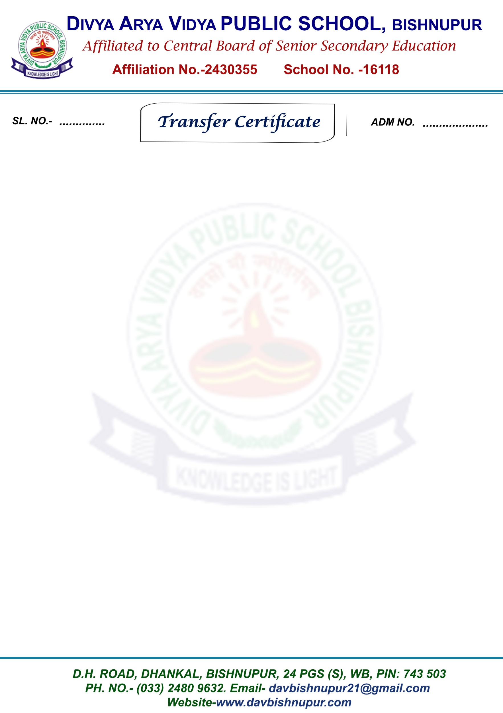

221 A2234/24

- Name of Pupil: SURBHI SINHA
- Father’s/Guardians Name: SHASHI KUMAR SINHA
- Mother’s Name: REENA SINHA
- Date of Birth: 25-09-2008
- (In words): Twenty Five September Two Thousand Eight
- Nationality: INDIAN
- Whether the candidate belongs to schedule Caste or Schedule Tribe or OBC: General
- Date of first Admission in the school in class:06-04-2024, CLASS- XI Science
- Class in which the pupil last studied (in Figures): CLASS- XI Science
- School/Board Annual examination last taken with result: No
- Whether failed, if so once/twice in the same class: NO
- Whether qualified for promotion to the higher class: if so, to which class (in fig): XII SCIENCE
- Month up to which the pupil has paid school dues: March, 2025
- Any fees concession available of if so, the nature of such concession: No
- Total no of working days in the academic session: 199
- Total no of working days pupil present in school: 190
- Whether NNC Cadet/ Boy Scout/Girl guide (details may be Given): N.A
- Games played or extracurricular activities in which the pupil usually took part: N.A
- General conduct: GOOD
- Date of application for certificate: 28-03-2025
- Date of issue of certificate: 06-04-2025
- Reason for leaving the school: Parents Option
- Any other remarks: N.A

________________________ __________________________ __________________________
Class Teacher Signature Checked by Principal Signature (Full name and designation)

